WEB Quest 105 All About Colour
Items in blue offer some information and notes and items underlined are links to help you get answers you should find more links on the Internet to help you answer questions
Questions are numbered and may be highlighted = answer where you see this Answer: (there are 11 questions to answer)

All About Colour
There are few things in design that are more subjective—or more important—than the use of color. A color that can evoke one reaction in one person may evoke the opposite reaction in another, due to culture, prior association, or even just personal preference.
Color theory is a science and art unto itself, which some build entire careers on, as color consultants or sometimes brand consultants. Knowing the effects color has on a majority of people is an incredibly valuable expertise that designers can master and offer to their clients.
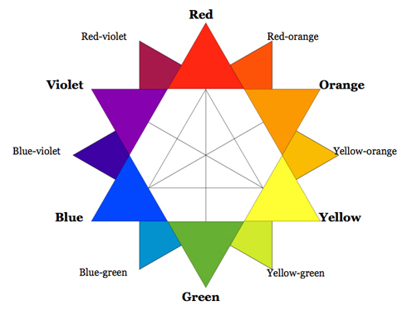
Exercise Starts here:
- Complete all numbered exercises
- Complete all numbered questions highlighted questions

- Save this document as <your surname> about colour.doc to your folder

1. Test 1 Using the table below decide which combination looks best to you.
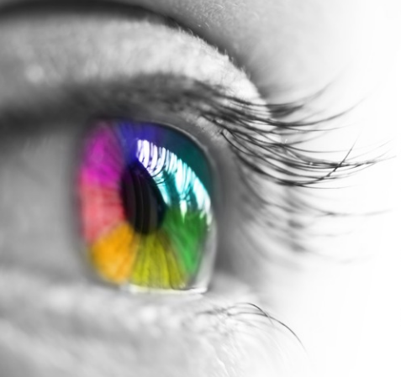
Your Answer: I prefer no. __________

Use this table to change font colour and background for test 2
1 | 2 | 3 | 4
FONT COLOUR | FONT COLOUR | FONT COLOUR | FONT COLOUR
5 | 6 | 7 | 8
FONT COLOUR | FONT COLOUR | FONT COLOUR | FONT COLOUR

2. Test 2 Test out different (at least three) font colours on each cell with different backgrounds
Which set of colours works best for your eyes for all three cells
Answer: Copy to the table below the font and background that you like most for each.

1 | 2 | 3
FONT COLOUR | FONT COLOUR | FONT COLOUR

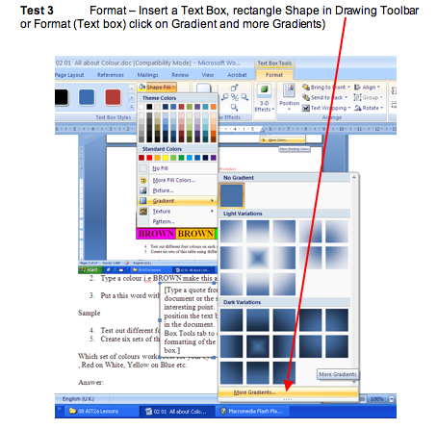

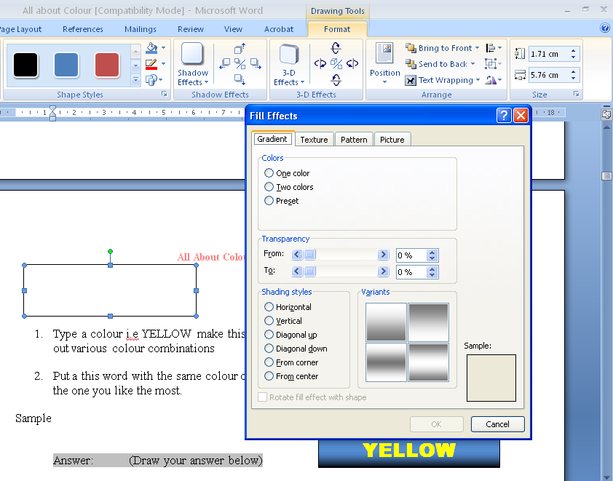

Type a Font colour i.e. YELLOW make this a yellow ARIAL BLACK font colour bold centred 20 pt and test out various colour combinations

Put a this word with the same colour on top of different gradients until you find the one you like the most.

YELLOW
Sample

Answer: (Draw your answer below)

3. Test 3 With reference to the colour wheel see how colour impacts visually, emotionally.

Graphic Design and Color Complements

Color complements, colors that set each other off, they complement each other. These are colors that are opposite on the color wheel, such as blue and orange.
http://www.color-wheel-pro.com/color-theory-basics.html
- Exercise: Insert a graphic that shows that complementary colours sit opposite one another on a colour wheel.

Graphic Design and Color Depth

Color depth, colors can recede or jump forward. Remember that some colors seem to fall back such as blue, black, dark green, and brown. Other colors will seem to step forward such as white, yellow, red, and orange. This is why if you have a bright orange background it may seem to fight with any text or images that you place on it. The orange will always seem to move forward.
Answer:Which colour from the wheel is most appealing to your eye?
Draw an arrow to your colour

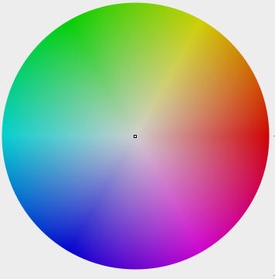

Answer: My colour is shown here
(Draw a text box filled with your colour – Format Fill)

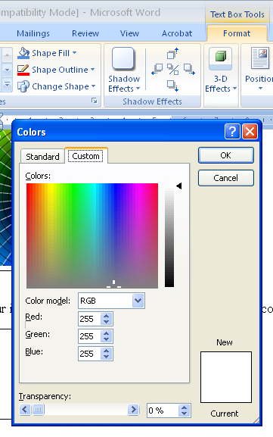

Find the R G B of your colour (Red, Green and Blue = RGB)

Answer: My Red Green Blue code is R= B= G=

NOTES & MORE QUESTIONS
4. Test 4
All About Colour (some examples on this page…)

Using colour is a difficult choice, which looks better, hard on Soft Light or on Dark?
Look at the blocks below which looks better?

Answer: delete not selected 1 2 3 4

1 | 2
HELLO | HELLO
3 | 4
HELLO | HELLO

When using colour remember some golden rules

Strong colours complement soft colours, Red on dark blue, is hard to view, but red on light blue is much easier on the eye.

Change the font colour to see which works for you leave it changed

1 | 2
HELLO | HELLO
3 | 4
HELLO | HELLO

Psychological/Emotional Variables
People have emotional responses to colour. For example, red is regarded as a "hot" colour that provokes aggression—we often use the term "seeing red" when someone is mad—while blues are cool and relaxing. We associate black with death, but black also evokes a sense of dignity. We associate white with purity and green with fertility. Being "in the red" is bad financial news while being "in the pink" means you're healthy.

People with having an aggressive session are put into light blue or light green rooms – this is a supposed to be a calming colour – That is why prisons and hospitals and some schools use light green for all the wall colours!

Red cars may unduly attract attention, while more sedately coloured vehicles often escape notice. Apart from blueberries and blue M&Ms, there is no blue food. Blue is regarded as an appetite suppressant (other than blueberries, blue does not occur naturally in any food item).

http://dba.med.sc.edu/price/irf/Adobe_tg/color/variables.html

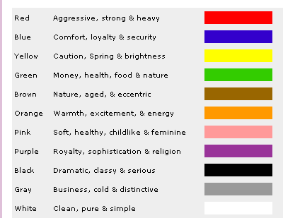

Find one more emotion for each colour from these web pages (fill in the colour)
http://www.color-wheel-pro.com/color-meaning.html

http://www.writedesignonline.com/resources/design/rules/color.html

Another excellent site
https://www.jenreviews.com/color-meaning/

5. Test 5
Exersize: Use the table with colour cells of appropriate colour - you choose
http://library.thinkquest.org/27066/psychology/nlcolorpsych.html
http://healing.about.com/od/colortherapy/tp/color_wardrobe.htm
Happy = Yellow |  | Technology = Silver
Inexpensive = Brown |  | Deity = White
Pure = White |  | Sexiness = Red (tomato)
Powerful = Red (tomato) |  | Bad Luck = Black
Good Luck = green |  | Mourning = Black
Dependable = Blue |  | Favorite color = Blue
Good tasting = Red (tomato) |  | Expensive = Gold
High Quality = Black |  | Least favorite color = Orange
Dignity = Purple |  | Nausea = Green
Psychological and emotional factors in colour perception also play a big role in defining colour. What two or more people see as a pure expression of a given colour may differ to a great degree. For example, we might define "yellow" using any of the following formulae:

H: 60  S: 100  L: 100 | R: 255  G: 255  B: 0 | L: 97  a: -20  b: 88 C: 0 | Y: 100  M: 0  K: 0

But looking at the colours below, which would you say is more purely "yellow" than the others?
Answer: No.

1 | 2 | 3 | 4 | 5


Is the one that most closely fits a formula, or is it the one that most closely matches what you think yellow should be?

6. Test 6
This is a significant issue in critical-critical fields like advertising since people respond to a product, or to the advertising of that product, by how they feel about the colours associated with it.

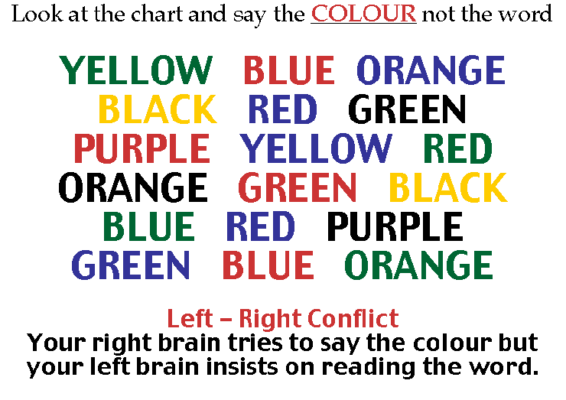

Did you have to stop and think about it Yes/No

or did you have to start again? Yes/No

7. Test 7

Physiological Variables
As we outlined in the preceding section, your eyes have a lot to do with the perception of colour. The sensitive-sensitive pigments in the cones of your eyes determine what signals are sent to your brain, giving you the sensation of colour. But what if those pigments are deficient?

One in 30 people are colour-blind to some extent. This is mostly a deficiency in seeing reds/greens or yellows/blues, but may also be a complete inability to distinguish colours.
- Exercise: Insert six table cells with different colour backgrounds and different colour fonts

Make a table 4 columns by 3 rows and fill each cell with a different solid colour, then add some text in bold (all the same colour) select which looks best.

Now select all the fonts in the cells and change the font colour

Select the next best combination when you change all the font colours to another colour. (It will probably not be the same cell.) but it should stand out immediately.

Write down or save thee colour combinations that really work for you
Note: (A useful chart to help you select some great colour combinations)
COLOUR | COLOUR | COLOUR | COLOUR
COLOUR | COLOUR | COLOUR | COLOUR
COLOUR | COLOUR | COLOUR | COLOUR
COLOUR | COLOUR | COLOUR | COLOUR

Answer

Answer

Answer

Environmental Variables
The major environmental variable concerns the kind of ambient light under which a colour is seen. This is directly related to the spectral power distributions discussed earlier. What we see outdoors is illuminated by the sun which is a, roughly, 6000K source. Light from artificial sources is rarely that bright. Since luminance is an important factor in seeing colour, the brightness of your environment will have a lot to do with the colour you see.

Metamerism
Another aspect of lighting is the issue of metamerism. Two objects may appear to be identical colours under a certain kind of light, yet under another kind of light they may appear distinctly different:

Metamerism is caused by two collared objects with differing spectral reflections (known as metamers) but which, under light of a particular spectral power distribution, provoke the same stimulus in the r, g, and b cones of the human eye.
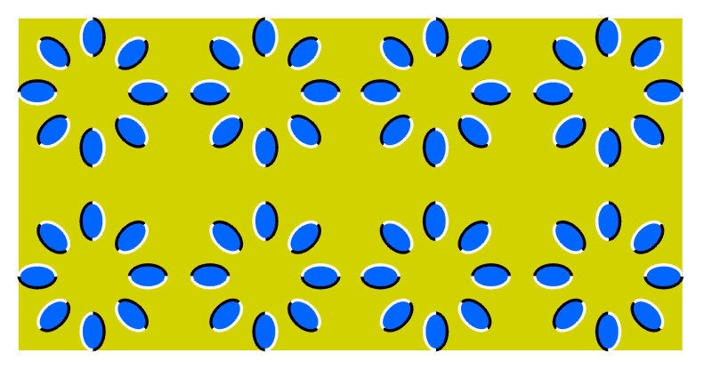
Achromatic Simultaneous Contrast
Another environmental variable is what is called achromatic simultaneous contrast. This is the juxtaposition of differing colours that affect each other. This can be seen in the illustration below:

1 2

3 4

The red dots in each quarter have the same spectral reflectance; however, due to the colours in each quarter that surround them, the dots appear darker or lighter than each other. The stimulus to the eye of the surrounding colour affects the stimulus of the red dot.

Answer: which red dot is darker 1 2 3 4

Look at the next image – YES it is a static image but what is happening to your eyes?

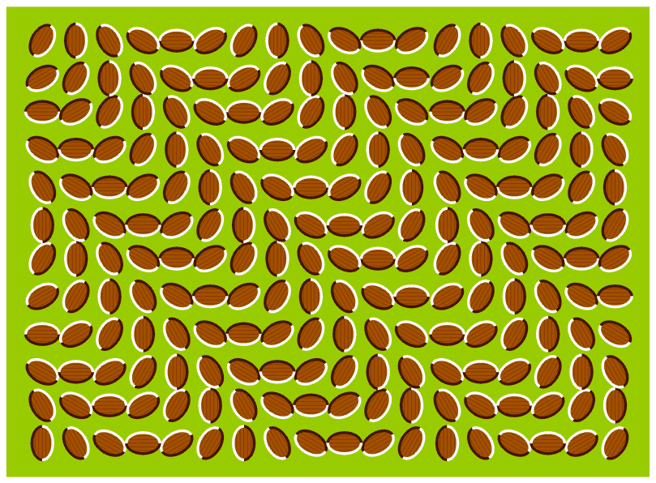

Look at the picture above :- try to explain why a still image appears to be moving:
(See more samples at the end of this document)

Answer:

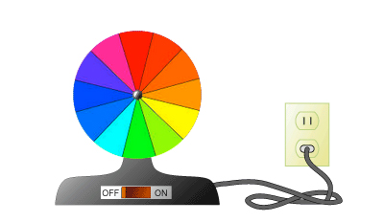
- If you were to spin the colour wheel what colour would the wheel reveal?

Your Answer

See end of document for answer

8. Test 8 Image reflection

Which image works best for you

Create a similar image below which you feel supports good use of colour

Test 9

Create a graduated rext in any program suitable

If using graduated colours consider using a shadow on the text, using Power Point on graduated slides ALWAYS use shadow.

- Create some text in a power point and add a shadow
Hello

Hello
Hello

Why not use gradients in text the enhance your words
Gradient

- Use Drop Shadows and make them soft

Photoshop Fonts
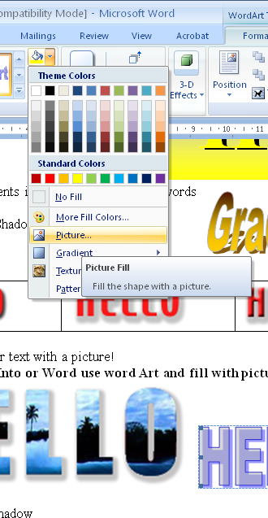
- Colour your text with a picture! Remember use a shadow

Photoshop Paste Into or Word use word Art and fill with picture

- Make up a new set of fonts

Test 10 Create some font mixers to replace these

Black on Orange

Yellow on Green

Blue on Light Blue

Brown on Light Brown

Yellow on Blue

Blue on Yellow works well Purple on Brown does not work

- Create a font set of your best choice of soft colour combinations.

My Font set Select all change the font pick out the best colour balanced cells put that into the box below (make three = your best combination of colours.
FONT | FONT | FONT | FONT | FONT
FONT | FONT | FONT | FONT | FONT
FONT | FONT | FONT | FONT | FONT
FONT | FONT | FONT | FONT | FONT
FONT | FONT | FONT | FONT | FONT
FONT | FONT | FONT | FONT | FONT

Your best three combinations answers

1 | 2 | 3

Gradient set

YELLOW
2

3

4

5

6
If you Spin the wheel Answer = White

END of Questions

Text over pictures is hard to read be careful when using text over a coloured image
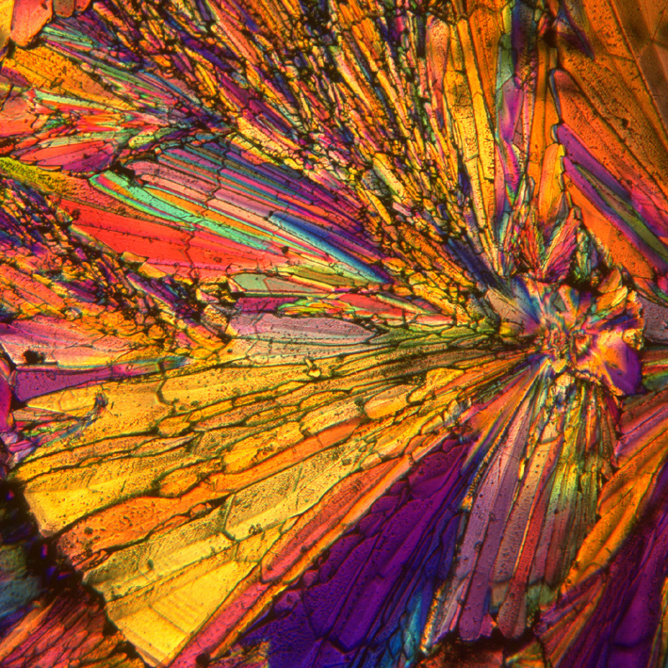
The Box

Some time ago a mother punished her 5-year-old daughter for wasting a roll of expensive gold wrapping paper. Money was tight and she became even more upset when the child used the gold paper to decorate a box to put under the Christmas tree.

Nevertheless, the little girl brought the gift box to her mother the next morning and said, "This is for you, Momma."

She embarrassed the mother earlier over reaction, but her anger flared again when she opened the box and found it was empty.

She spoke to her daughter in a harsh manner. "Don't you know, young lady, when you give someone a present there's supposed to be something inside the package?"

She had tears in her eyes and said, "Oh, Momma, it's not empty! I blew kisses into it until it was full."

The mother was crushed. She fell on her knees and put her arms around her little girl, and she begged her forgiveness for her thoughtless anger.

An accident took the life of the child only a short time later, and it is told that the mother kept that gold box by her bed for all the years of her life. Whenever she was discouraged or faced difficult problems she would open the box and take out an imaginary kiss and remember the love of the child who had put it there.

In a very real sense, each of us, as human beings, has been given a Golden box filled with unconditional love and kisses from our children, family, friends and God.

There is no more precious possession anyone could hold.

Friends are like angels who lift us to our feet, when our wings have trouble remembering how to fly.

Create a Set of Corporate Colours

Publish a Flyer

Produce a Brochure advertising your company

Explanatory Notes

The RGB (CMY) Colour Model
RGB and its subset CMY form the most basic and well-known colour model. This model bears closest resemblance to how we perceive colour. It also corresponds to the principles of additive and subtractive colours.

Additive Colours
Mixing spectral light in varying combinations creates additive colours. The most common examples of this are television screens and computer monitors, who produce collared pixels by firing red, green, and blue electron guns at phosphors on the television or monitor screen.

More precisely, additive colour is produced by any combination of solid spectral colours that are optically mixed by being placed closely together, or by being presented in very rapid succession. Under these circumstances, two or more colours may be perceived as one colour.

This can be illustrated by a technique used in the earliest experiments with additive colours: colour wheels. These are disks whose surface is divided into areas of solid colour. When attached to a motor and spun at high speed, the human eye cannot distinguish between the separate colours and sees them instead as a composite of the colours on the disk:

Subtractive Colours
Subtractive colours are seen when pigments in an object absorb certain wavelengths of white light while reflecting the rest. We see examples of this all around us. Any collared object, whether natural or man-made, absorbs some wavelengths of light and reflects or transmits others; the wavelengths left in the reflected/transmitted light make up the colour we see.

This is the nature of colour print production and cyan, magenta, and yellow, as used in four-colour process printing, are considered to be the subtractive primaries. The subtractive colour model in printing operates not only with CMY(K), but also with spot colours, that is, pre-mixed inks.

RGB
Red, green, and blue are the primary stimuli for human colour perception and are the primary additive colours. The relationship between the colours can be seen in this illustration:

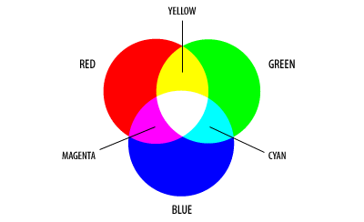
The secondary colours of RGB, cyan, magenta, and yellow, are formed by the mixture of two of the primaries and the exclusion of the third. Red and green combine to make yellow, green and blue make cyan, blue and red make magenta.

The combination of red, green, and blue in full intensity makes white. White light is created when all colours of the EM spectrum converge in full intensity.

The importance of RGB as a colour model is that it relates very closely to the way we perceive colour with the r g b receptors in our retinas. RGB is the basic colour model used in television or any other medium that projects the colour. It is the basic colour model on computers and is used for Web graphics, but it cannot be used for print production.

CMY(K)
Cyan, magenta, and yellow correspond roughly to the primary colours in art production: red, blue, and yellow. In the illustration below, you can see the CMY counterpart to the RGB model shown above:

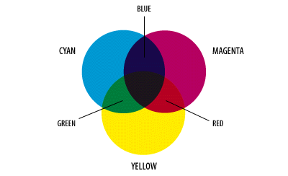
Just as the primary colours of CMY are the secondary colours of RGB, the primary colours of RGB are the secondary colours of CMY. But as the illustrations show, the colours created by the subtractive model of CMY don't look exactly like the colours created in the additive model of RGB. Particularly, CMY cannot reproduce the brightness of RGB colours.

Just for fun more static images…

